# Recipe app features

## Common

Ability to add own grocery list

Personalized recommendations

Link to social media / sharing recipes on the app

Nutritional information

## Uncommon:

Ingredient-based Recipes

Dietary customization

Cooking videos as a guide

AI-voice guide

Recipe scaling - recipes change based off food-serving size

Timers – Users can start specific steps after a certain amount of time

# UI/UX design schemes:

Taken from: [Cooking Together — Cooking App. UX Case Study | by Ruchi Singh | Medium](https://medium.com/@singhruchi1011/cooking-together-cooking-app-bfdc92bbfb71)

**Recognition rather than recall**: Minimize user’s memory load by making options visible, meaning user will not have to remember information from one pane to another.

**Flexibility and efficiency of use**: Use accelerators (UI features that speeds up interaction) for users to tailor frequent actions.

**Aesthetic and minimalist design**: Only necessary information in dialogue boxes.

**Help and Documentation**: ability to provide help with documentation, steps on how to use system or form of guidance.

# Choosing dev tools etc.

* Ionic – used for building cross-platform mobile, web apps by using HTML, CSS, and java/typescript
  + Compatible with VS Code and Android studio
* Flutter – mobile UI framework (used for making native apps in iOS and Android)
  + Makes use of the **Dart** programming language
  + Compatible with VS Code and Android Studio
* Live Preview – preview browser when server has not yet been created, does not support modern JS features.
* Live Server – Has live web app review and live browser reload

(Expanding on this information below)

**Comparing Ionic, Flutter, Native React:**Each framework has its strengths and weaknesses which what we’ll explore here:

* Ionic

Strengths:

* + If building an app with web technologies is essential
  + Considered very easy to learn
  + Allows the use of HTML, CSS and JavaScript which makes native apps look and feel like they were built with native apps
  + Offers pre-designed UI components, making it easier for developers to create apps that are both appealing and functional.
  + Allows for the development of apps for iOS and the web
  + Built on top of angular 🡪 Makes it easier to learn the ionic framework
  + Has a large community that provides support, as well as providing plugins and extensions for the framework
  + Offers the “Ionic Capacitor” feature, allowing developers to build apps that run natively on desktop platforms such as Windows and macOS 🡪 allows developers to leverage their existing web development skills to create cross platform apps without sacrificing performance or design quality

Weakness:

* + Has a slightly lower performance compared to fully native or flutter apps, especially for complex animations and graphics
  + It also may not provide the same level of native look and feel when compared to the other frameworks such as Flutter and React Native

Examples of apps and websites built with framework:

* JustWatch website
* Shipt app
* McDonald's Türkiye

[Top 5 Popular Apps Built with Ionic Framework | InfoStride](https://infostride.com/apps-built-with-ionic/)

* Flutter

Strengths:

* + Makes use of the Skia graphics library to render all components so the application has a native look and feel on both iOS and android
  + Has a reactive framework and stateful hot reload 🡪 allowing for lightning-fast rendering and a very smooth development experience
  + May be new but has a rapidly growing ecosystem of packages and is all supported by Google
  + Has a single codebase to build apps for both iOS and android, as well as web and desktop 🡪 would make fixing bugs way easier

Weakness:

* + Requires learning dart which could be considered a steep learning curve for developers unfamiliar with the dart programming language
  + Typically, apps made using flutter have a larger app size compared to React Native and Ionic
  + Web support is improving but is not as mature as Ionic

Examples of apps and websites built with framework:

* Alibaba website
* eBay Motors website
* GooglePay, Google Classroom

[List of Flutter apps | It's All Widgets! (itsallwidgets.com)](https://itsallwidgets.com/#/)

* React Native

Strengths:

* + Very popular choice amongst developers
  + It makes use of React, which is a powerful and flexible JavaScript library to make mobile apps for both iOS and android
  + Can build for both platforms using on code base 🡪 saves times and resources and no compromise on user experience or app performance
  + Allows for hot reloading, meaning changes can be seen in app without requiring a full build
  + Has a large community 🡪 plenty of resources(libraries)
  + Makes use of React’s declarative programming paradigm, which makes writing UI components easier and more intuitive.

Weakness:

* Has slightly lower performance compared to flutter, especially when it comes to complex animations and heavy computations
* The UI can vary between platforms since it uses native components that can behave differently on iOS and android
* It sometimes requires you to build native code for complex functionalities which can add to the development time

Examples of apps and websites built with framework:

* Facebook
* Walmart
* Uber Eats, Discord, Wix

[Top 10 Examples of React Native Apps in 2024 (brainhub.eu)](https://brainhub.eu/library/react-native-apps#:~:text=Gyroscope%20&%20React%20Native%20Gyroscope%20is%20another,life;%20it's%20the%20health%20app%20on%20steroids.)

|  |  |  |  |
| --- | --- | --- | --- |
| Feature | React Native | Flutter | Ionic |
| Language | JavaScript | Dart | HTML, CSS, JavaScript |
| Performance | Good | Excellent | Good |
| UI Consistency | Varies (uses native components) | Consistent (custom rendering) | Varies (web-based) |
| Learning Curve | |  | | --- | | Moderate (JavaScript) |  |  | | --- | |  | | Steeper (Dart) | Easy (web technologies) |
| Community | Large | Growing rapidly | Large |
| Cross-Platform | iOS, Android | iOS, Android, Web (expanding) | iOS, Android, Web |
| Native Feel | Good | Excellent | Decent |
| Web Support | Limited (separate effort) | Improving | Strong |
| Ecosystem | Extensive | Expanding | Extensive |

**Final Thoughts:**From what I’ve gathered from various websites and chatgpt, Ionic seems to be the best choice since it offers seamless web and mobile integration with technologies that we are all familiar with. However on that note, if we want high performance and a native-like experience across all platforms then Flutter is the better option, provided we learn Dart :/. Then React Native is sort of in the middle with strong community support and good overall performance.

Sources consulted :  
[Ionic vs. React Native vs. Flutter: What's Best for 2024? (deduxer.studio)](https://www.deduxer.studio/blog/ionic-vs-react-native-vs-flutter-whats-best-for-2024)

[I built the same app with Flutter, React Native, and Ionic | by Francisco Magalhaes | Medium](https://medium.com/@fmmagalhaes/i-built-the-same-app-with-flutter-react-native-and-ionic-33ff8b358562) (Good article, listed some problems we might encounter as we make use of our chosen framework, I suggest you read it)

[Ionic vs. React Native vs. Flutter: What’s Best for 2023? | Medium](https://medium.com/@nautilustechlabs/ionic-vs-react-native-vs-flutter-whats-best-for-2023-a8ae061d5542)

[The Flutter vs. Ionic Debate - Which One is Better? (intelivita.com)](https://www.intelivita.com/blog/flutter-vs-ionic/#:~:text=%2DIonic:%20If%20you%20want%20to,use%20both%20Ionic%20and%20Flutter.)

And ChatGPT

**APIs to consider**: [Recipe API – 12 Most Popular Recipe APIs [Q3, 2024] (suggestic.com)](https://suggestic.com/blog/recipe-api-ultimate-list)

* YouTube API - YouTube videos to be embedded
* Spoonacular API – Free with limited use
* Suggestic Recipe API - create meal plans based off preferences
  + Free for developer version but only for 30 days
* Zestful Data API – make recipes searchable and build shopping lists
  + Has a 30 ingredient parses per day free trial
* TheMealDB API – contains a database for multiple recipes
  + Is free and includes instructions, ingredients and images.
  + However after looking into it, seems that we can not get all the recipes (in their database, we are limited to 100) for free unless we support their paypal: <https://www.themealdb.com/api/json/>

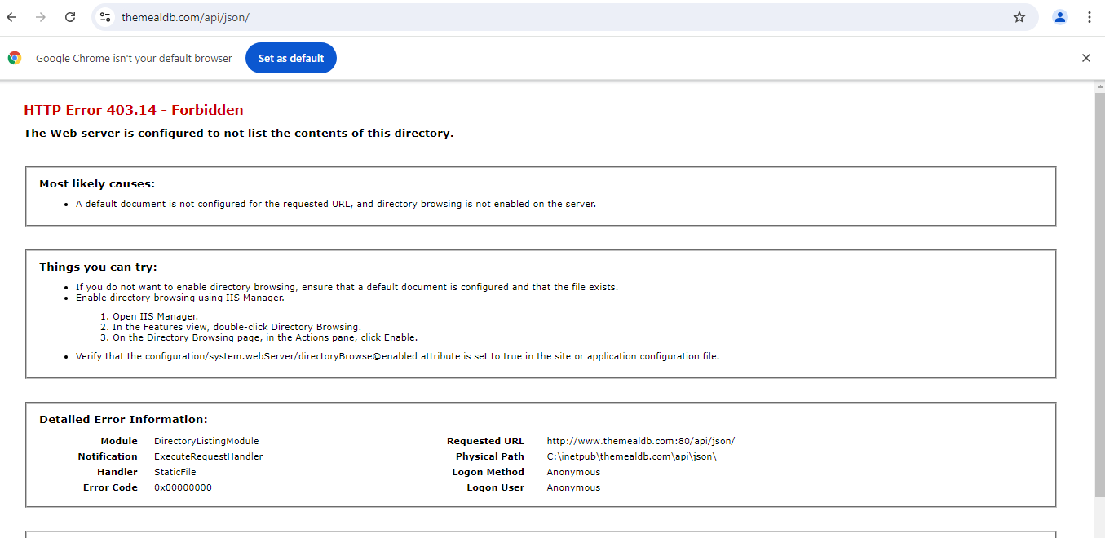

However, there is a work around, we can search for recipe names by just inputting the first letter of the recipe and get a bunch of results to get our 100 recipes. 🡪 which we can use to populate our own database.

## Prototyping:

* Figma – Free with some limitations such as a maximum of 3 projects
* Mockflow – mainly for designing the wireframe
* Canva – Free and allows multiple customizable screens, not sure if buttons can be animated.

# Use Case (draft)

Users:

* Guest user (Unregistered)
  + Browse recipes
  + Bookmark recipes
  + Able to share links to recipes
  + Won’t have personalised meals
* Admin
  + User Management
  + Recipe Management
  + Generate reports
  + Monitor logs
* User (Registered)
  + Login
  + Create and plan meals
  + Possibly leave reviews
  + 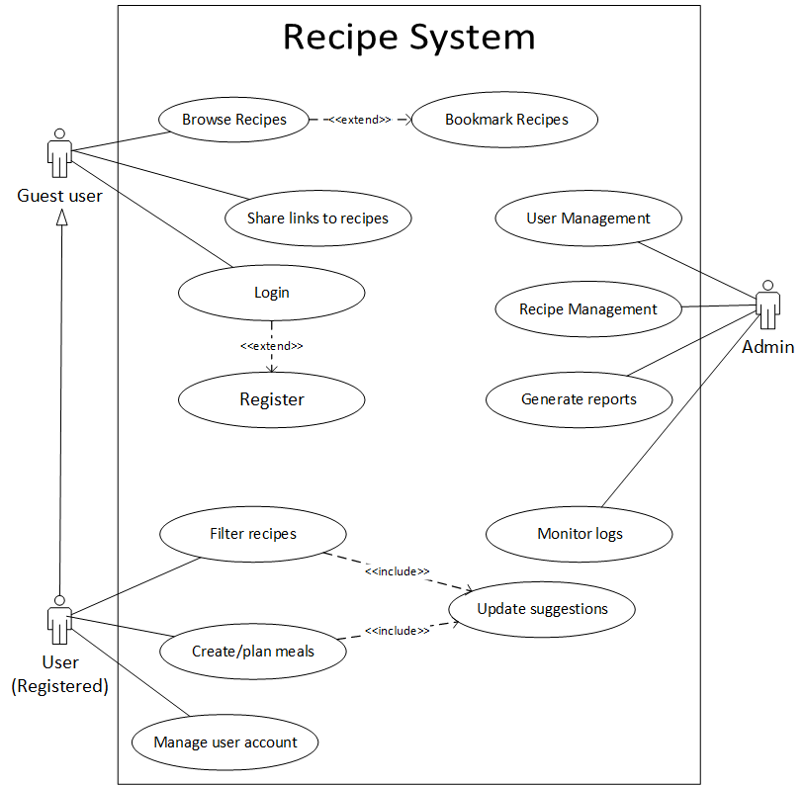Manage user account